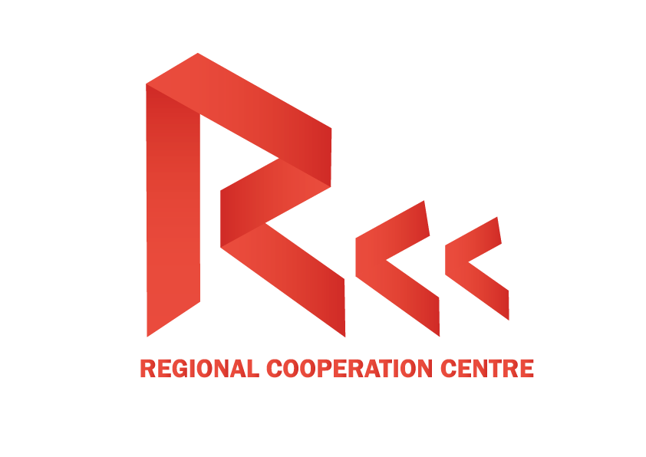

**Tbilisi Security Conference**

**Venue:** Hualing Tbilisi

**Working language**: English/Georgian

**Date:** 30 September, 2016

**Session 1. Black Sea Region Security Challenges**

10:00 – 11:00 Registration

11:00 - 11:30 Opening Remarks

Mr. Mr. William Lahue The Head of the NATO Liaison Office (TBC) Mr Zeki Levent Gümrükçü Ambassador of Turkey to Georgia (TBC)

11:30 - 12:30 Panel 1: Black Sea Security Challenges and Georgia’s Prospect to NATO membership after the Warsaw Summit.

**Panel Speakers:**

Moderator: Mr. Giorgi Rukhadze, ECPM Vice President

Mr. Nodar Kharshiladze, *Senior Fellow, GFSIS*

Mrs. Khatuna Lagazidze, *Security Expert, Georgian Institute for European Values.*

Mr. Tornike Sharashenidze, *Head of IR Faculty, GIPA*

12:30 – 12:45 Live I from Ukraine. Yulia Timoshenko. Leader of Batkivshchyna party

12:45- 13:00 Q and A Session

13:00 – 14:00 Lunch

**Session 2. Terrorism threat in the region and the EU**

14:00 - 14:30 Opening Remarks

Mr. Peter Ostman, MP, ECPM President

14:30 – 15:30 Panel 1: Terrorism challenges in the wider black sea region and the continent. Situation in Syria, Turkey and the EU.

**Panel Speakers:**

Moderator: Mr. Nodar Kharshiladze, *Senior Fellow, GFSIS*

Mr. Nika Chitidze. *Prof. IBSU University.*

Mr. George Targamadze, *Senior Fellow, GFSIS*

Mr. Zurab Agladze, *Senior Fellow, Atlantic Council of Georgia*

15:30 – 15:45 Live from AK Party, Turkey

15:45 – 1600 Q and A Session

16:00-16:30 closing remarks.